**Crowdfunding Analysis Report**

# **Background**

Crowdfunding, a method of raising funds for a project or venture through the collective effort of donations, has been used by platforms such as Kickstarter and Indiegogo. These platforms have increased in popularity thanks to crowdfunding by indie creators and famous celebrities.

To start a successful a crowdfunding website, it is common to investigate past projects to analyze and find hidden trends that will help organizations reach their own crowdfunding goals.

# **Objectives**

An analysis of past Kickstarter projects will be conducted by organizing and analyzing a database of 1,000 projects to find hidden trends and insights to what could potentially lead to success.

# **Analysis**

The data set from previous projects was essentially broken down into 4 outcomes: Successful, Failed, Canceled, or Live. To find significant insights, the factors to what made campaigns successful were analyzed. There were 3 main factors considered.

1. Categories of campaigns
2. Time elapsed
3. Funding goal amount

## Categories

There were 9 main categories found in the data, with the main 3 being: Theater (34%), Film & Video (17.8%), and Music (17.5%) which account for 70% of all projects. When looking at the main 3 categories only, the success rate is 55.67%.

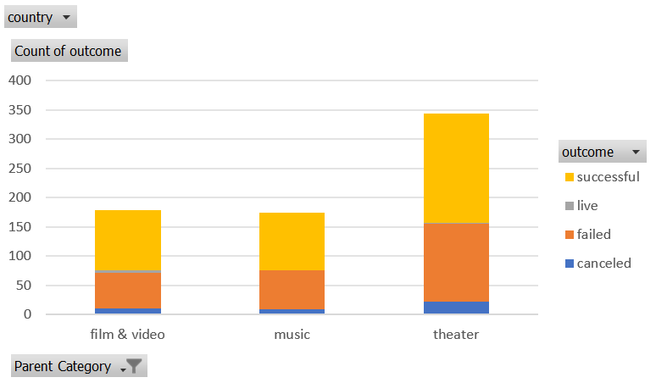

The success rate for the remaining 6 categories combined is 58%.

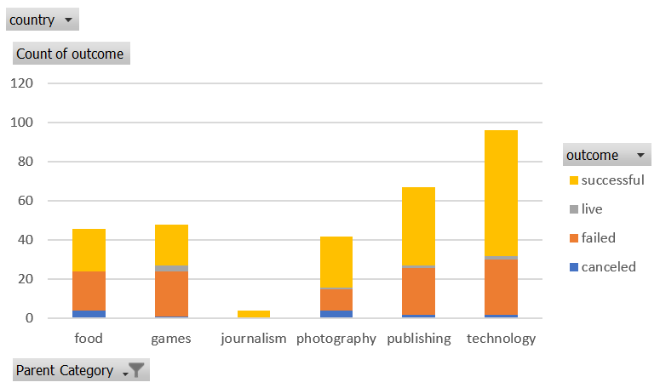

What we can gather from this data is that when looking at only successful and failed outcomes, campaigns that fall withing the categories of Technology, Photography and Film and Video have the greatest chance of success with percentages being:

* Technology (70%)
* Photography (70%)
* Film and Video (63%)

A key point is that these categories seem to receive the most attention, thus backers that are looking into supporting crowdfunding projects may want to look at these categories to funding projects in as they have the greatest chance of success.

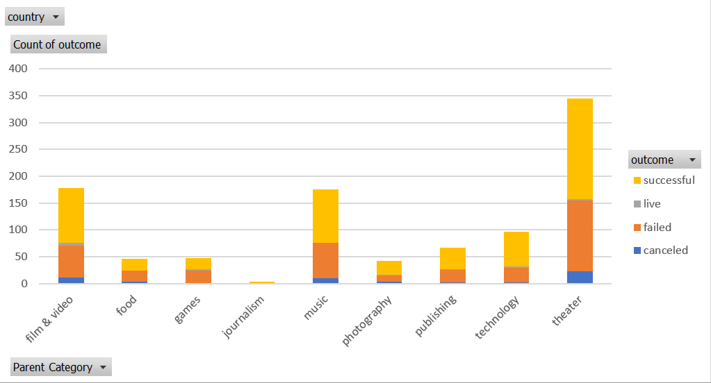

## Time Elapsed

With the given data, we can see that most projects from all categories peak in success through the months of May-July.

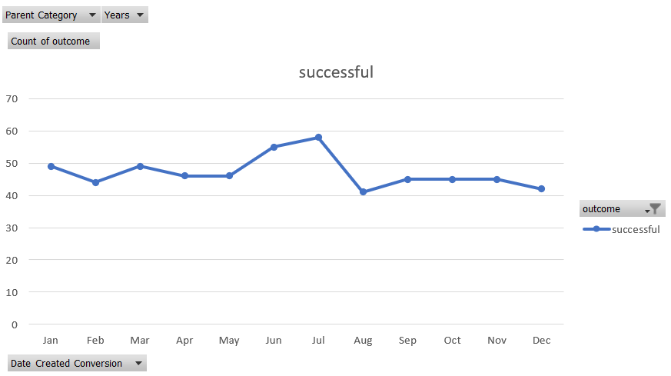

In contrast, failed and cancelled projects tend to be higher in the months of December-January.

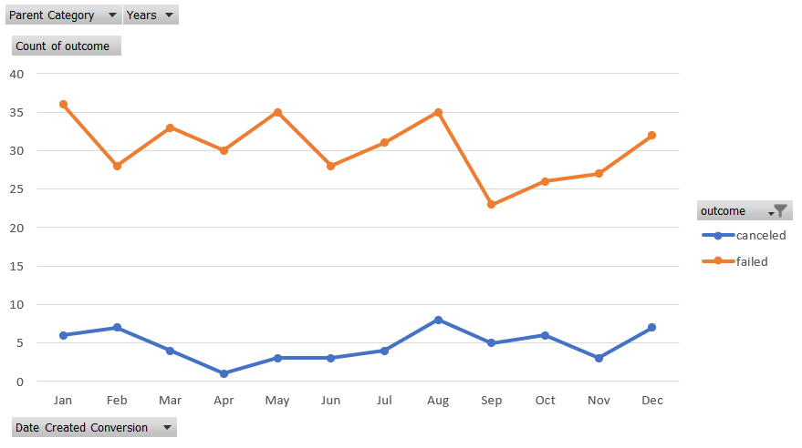

An interesting observation here may be that there may be seasonal factors that come into play, with higher success rates in the warmer months. However, the failed projects trend tends to spike up and down quite frequently. Thus, one should aim to set a timeline to reach the fundraising goal within one month of the initial start date.

## Funding Goal Amount

Given the data, there is a clear trend showing how projects tend to decline in success rate as the goal amount gets higher.

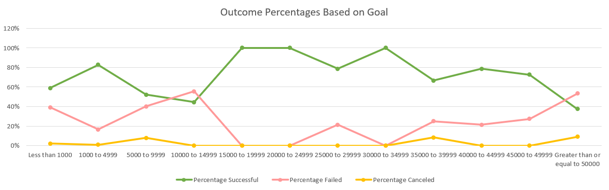

Most successful projects have kept their funding goals lower. Therefore, for a greater chance of a successful project it is recommended to aim for lower funding goals.

# Limitations

1. The sample size is small and there is not enough data and results for certain categories and subcategories to make more accurate analysis and statistical predictions.
2. Data from only 2 crowdfunding platforms is not varied enough. Results and data from other crowdfunding companies would help in gathering more insightful analysis.
3. The data is spread through a large range of years. Data would be more accurate if it were focused to only the las 3-5 years. More data from this range would be more advantageous for analysis and predictions.